**1. Create a Virtual Network in West US:**

* **In Azure Portal**:
  1. Go to "Virtual networks."
  2. Click on "Create."
  3. Select the **West US** region.
  4. Define a name, address space (20.0.0.0/16), and subnets.
  5. Review and create the virtual network.

**2. Create Another Virtual Network in South India:**

* **In Azure Portal**:
  1. Repeat the above steps for **South India**.
  2. Name the virtual network and provide an address space (10.1.0.0/16).
  3. Add subnets and deploy.

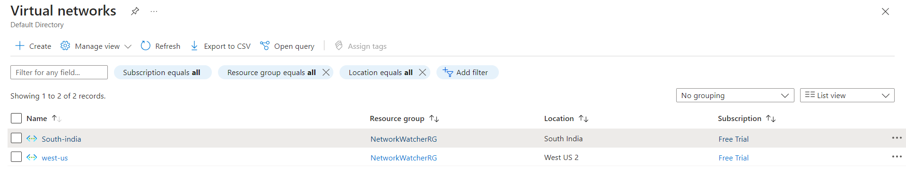

**3. Deploy a Virtual Machine in West US:**

* **In Azure Portal**:
  1. Go to "Virtual Machines."
  2. Click "Create."
  3. Select **West US** for the region.
  4. Assign the VM to the **West US Virtual Network** created earlier.
  5. Choose an OS image (windows), size, authentication, and storage.
  6. Complete the setup and launch the VM.

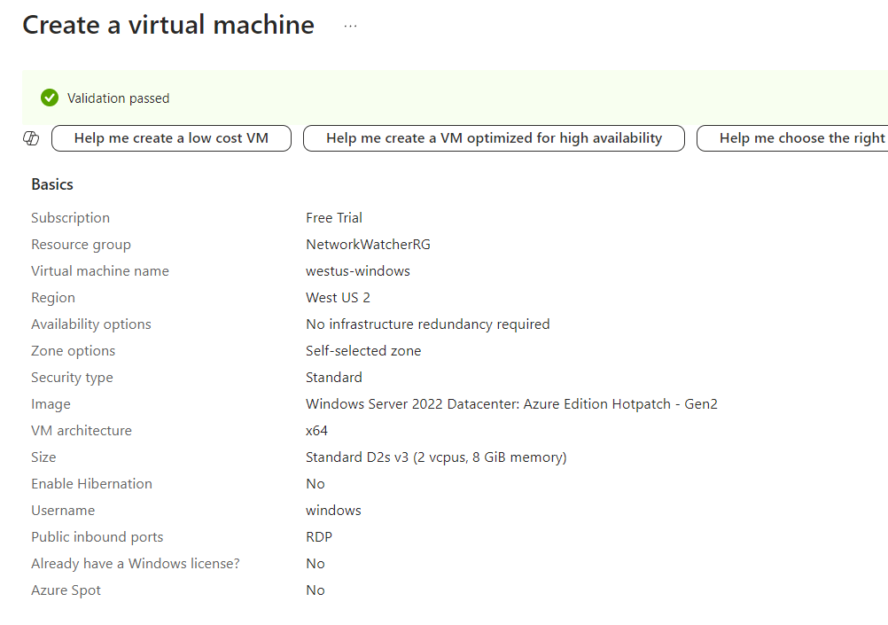

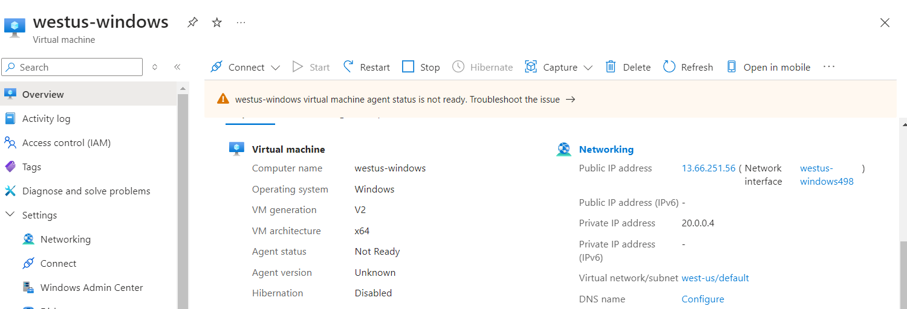

**4. Deploy a Virtual Machine in South India:**

* **In Azure Portal**:
  1. Repeat the steps to create another virtual machine in **South India**.
  2. Make sure the VM is connected to the **South India Virtual Network**.
  3. Complete deployment.

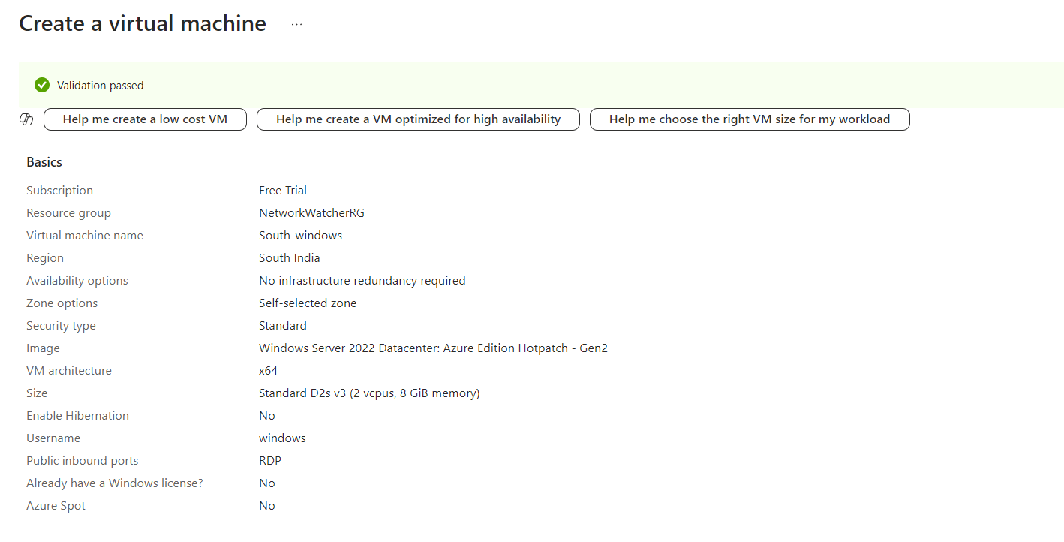

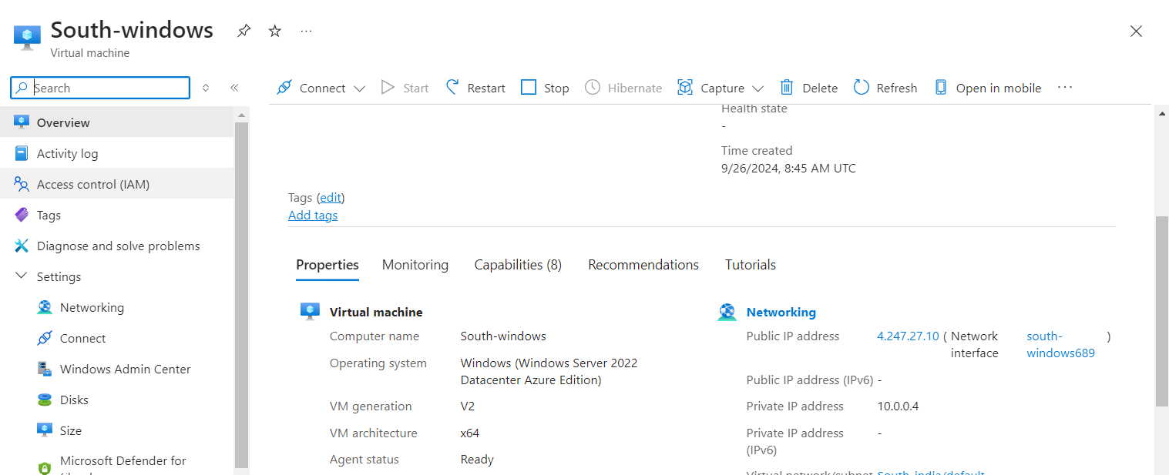

**5. Create VNet-to-VNet Peering:**

* **In Azure Portal**:
  1. Navigate to "Virtual networks" and select the **West US Virtual Network**.
  2. Under "Settings," select "Peerings," then "Add."
  3. Choose the **South India Virtual Network** to peer with.
  4. Ensure you enable "Allow virtual network access."
  5. Similarly, create a peer connection from the **South India Virtual Network** to **West US**.

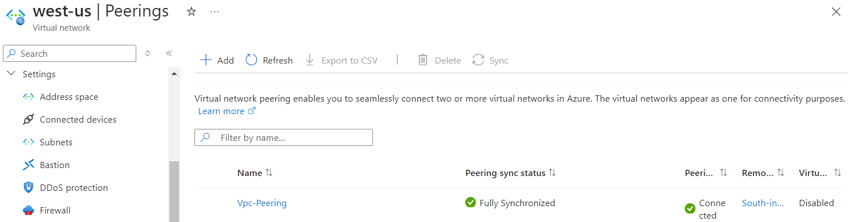

**6. Test VM Connectivity:**

* **Via RDP**:
  1. Connect to **VM1** (South India VM).
  2. Ping the private IP address of **VM2** (West US VM):

Ping 10.0.0.4

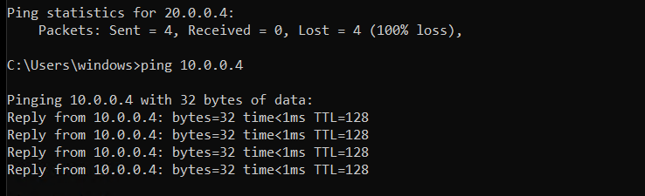

* 1. Ensure the ping is successful to verify connectivity.